UUFC Kitchen Instructions
Adopted 2013

Reviewed on : ____________________________________

Revised January 2015

Please Note: This manual is divided into sections, including one for our Guest Users. Should you have questions, problems or need information, call the UUFC office at 654-5959.

Table of Contents
UUFC Hospitality Time - OVERVIEW 2
Setting-Up for Hospitality Time 3
Where is Everything? 3
Basic Set Up in Social Room: Drinks on the counter; Food items on a table 3
Beverages on the Counter 3
Hot Beverages 3
Coffee Cups and Other Supplies 4
Refreshing Water 4
Food Table 4
Snacks and Nibbles 5
Kitchen and Social Room Clean-up 6
Leftovers 6
General Clean-Up 7
Finding and Re-ordering Housekeeping Supplies 9
Re-Ordering Supplies 9
Trash/Garbage – Recycling – Composting 10
Trash/Garbage 10
Recycling 10
Composting – Revised October 2014 11
Closing Checklist 12
APPENDICES
Instructions for BUNN Coffee Making System A1

UUFC Hospitality Time - OVERVIEW

We offer coffee, tea and a limited number of snacks most Sundays. A more elaborate selection of snacks is encouraged on Trading Post Sundays (Second Sunday of each month) special events, holidays and potlucks.

NOTE: Detailed information is available in UUFC Kitchen Instructions located in the wall pocket in the kitchen. It is also posted on our website (www.UUCF.org).

- Hospitality Time is held after the 10:30 service, and begins at 11:30 a.m. Set up is recommended at 9:30.

First thing: start Bunn unit – takes 15-20 minutes to heat the water in the reservoir.

- See posted instructions for preparing coffee and hot water for tea.

- Get out other service items including napkins, cups, sugar, spoons, cream/milk, and tea bags.

- Place a table in the middle of the room (two if needed). Optional: Cover with table cloth(s). Put donation jar in the middle of table.

- Check available snacks. Pick 3-4 items and place in serving dishes with a serving spoon or fork. Put chosen items and other donated snacks on the table.

- During Hospitality Time, refill snacks as needed.

- At 12:30 or whenever crowd dwindles to around 5-6 people, announce last call for coffee and tea.

- Put everything away and clean up the Social Room and Kitchen. See cleanup instructions on Page 6.

- If you are the last one out of the building, lock up! Refer to Page 12.

- It is the team captains’ responsibility to replenish supplies at the end of the month, using money from the donation jar (stored on middle shelf above Bunn unit). Inventory snacks according to the checklist on the clipboard in the wall-mounted holder.

Setting-Up for Hospitality Time

Where is Everything?

- Dishes, flatware, napkins, tablecloths and serving pieces: Doors and drawers in both the kitchen and social room have been labeled for your convenience.

- Aprons are hanging on the wall to the right of the refrigerator. Feel free to use one, and then place it in the white mesh laundry bag if/when soiled.

- Tables are stored in the closet in the Social Room.

- Tablecloths are in cabinet above the sink (use is optional)

- Snacks are in the cabinets above the pass-through window in covered plastic boxes and in the refrigerator. All snack foods are labeled “For UUFC Hospitality Only”. Please first check for boxes and bags of snacks which have already been opened before opening a new one.

- Flatware is located in the Social Room, including most serving pieces. When you empty the dishwasher, please put the flatware back in the SOCIAL ROOM drawers.

Basic Set Up in Social Room: Drinks on the counter; Food items on a table

All drawers and cabinet doors and most shelves are labeled for easy searching of hospitality supplies. Please help everyone by returning items to their proper storage location.

Beverages on the Counter

Hot Beverages
We use only fair trade coffee purchased from Equal Exchange, both Regular & Decaf. Coffee is stored in plastic containers in the cabinet above the Bunn Coffee Maker, with backup supplies stored on the top shelf of the same cabinet. (Do not freeze coffee).

Tea bags of black and herbal teas are stored in a tea caddy in the Social Room. Simply place the tea chest out on the counter next to the hot water (blue-topped) airpot.

Hot water should be dispensed in the Social Room from the Blue-topped airpot. Use stove top teakettle, electric tea kettle and/or the Bunn unit to heat water.

Detailed, step-by-step coffee-brewing instructions with photos are provided in the Appendices. They are also hung on the “Plug Hook” above the Bunn unit for quick referral.

Coffee Cups and Other Supplies
Coffee Cups: Clean cups/mugs are stored in a lower cupboard. Sometimes clean cups are in the dishwasher (please empty the dishwasher, since you will need to reload during cleanup). Place coffee cups (open side up) next to the airpots on the counter in the Social Room.

Creamer: Milk is stored in the refrigerator once opened, so check there first. We use ultra-Pasteurized “boxed milk” to maintain freshness longer and it is stored on a top shelf in the cupboard above the Bunn Coffee Maker. Always label a newly opened carton with date-opened information. Place milk in a small pitcher or pitchers.

Sugar: Sugar bowl should be filled with sugar stored in labeled canister and placed next to creamer(s) on the counter. Put out sugar substitutes in a bowl or a plastic water cup.

Set out shallow dessert plates in front of coffee airpots as drip catchers and another plate as a spoon rests.

Refreshing Water
For those who would prefer simpler refreshment, please set out at least a half-dozen glasses or plastic tumblers along with a pitcher of cold water, preferably dispensed from door of the refrigerator (filtered). Water pitchers are stored in labeled cabinet above sink. Plastic cups are stored in bottom cabinet under pass-thru.

Food Table

- If you would like, cover the food table with a tablecloth stored in cabinet above kitchen sink.

- Place napkins, located in labeled drawer in social room, on the table. Avoid using plates if possible.

- Place donation jar on table (donations help defray the costs of snacks)

- Set out nuts and other dry mixes in bowls with serving spoons for scooping. Let’s discourage scooping with one’s hands.

- Avoid throwing away original food wraps or snack containers you open until it is clear they are not needed for rewrapping and taking leftovers home. Foil and food wraps can be folded and placed under the platter or bowl for quick retrieval and covering leftovers at the end.

- Place rolling cart with gray plastic tubs next to Social Room door for dirty cups, glasses and flatware. Also, be certain a wastebasket for dirty napkins is next to the cart.

Snacks and Nibbles
Regular Snacks/Nibbles: As a Green Sanctuary we strive to keep snacks simple, environmentally friendly and healthy. We also wish to offer options that are appropriate for those avoiding gluten. On Trading Post Sundays, holidays or special events we encourage Hospitality hosts to contribute homemade goodies. Please see appendices for more detailed guidelines.

- Nuts, chips, crackers, cheese, salsa and other non-sweet snack items supplied by the Fellowship are purchased by the Hospitality Committee, labeled and stored in kitchen cupboards and the refrigerator.

- Place a label “USE ONLY FOR UUFC HOSPITALITY” on all new snack items when they are delivered and Please write the date the package was opened on the label.

- Avoid throwing away original food wraps or snack containers you open until it is clear they are not needed for rewrapping and taking leftovers home. Foil and food wraps can be folded and placed under the platter or bowl for quick retrieval and covering leftovers at the end.

Special Snacks: ALL food donations from Fellowship members, friends and guests are ALWAYS gratefully received.

- If people bring food, please encourage them to take leftovers home, including drinks or condiments like salad dressing. The only exception is food that can be used again for hospitality the next week or so: Please place it in the refrigerator labeled and dated.

Using the STOVE and MICROWAVE

SAFETY
- For safety, no frying is allowed in the kitchen per the fire marshal.

- The oven and burners can be used for warming or cooking. PLEASE MAKE CERTAIN ALL BURNERS AND OVEN ARE TURNED OFF BEFORE LEAVING.

- A FIRE EXTINGUISHER is LOCATED IN THE KITCHEN on the WALL NEXT TO THE DOOR. Please take a moment to read how to use it.

- Instructions for using the microwave are available in the wall pocket.

Kitchen and Social Room Clean-up

Hospitality Time is usually 11:30-12:30, or when the crowd has dwindled to a few people. Before removing food or coffee announce, “last call for food and coffee”.

Leftovers

- Dispose of leftover milk from small pitchers/creamers. Do not return milk to original containers.

- Empty sugar bowl into labeled plastic canister and return to cabinet.

- Throw out all leftovers such as crackers, chips, nuts. Do not return them to their containers or bags.

- Plastic wrap, food storage bags, wax paper and aluminum foil are stored in a drawer across from the sink as well as in the cabinet directly underneath that drawer. Please select the most appropriate material and/or size for your need.

- No alcohol can be stored at UUFC. Make certain it is removed from the building and grounds (SEE ALCOHOL POLICY).

Using the REFRIGERATOR

- ALL opened items must be clearly labeled with DATE and USE. Labels and pen are available in the wall-mounted holder attached to a clipboard.

- Please alert your team coordinator if you are concerned about unmarked items. If these foods are obviously expired and not labeled, please dispose of them.

- Wipe out the refrigerator as needed.

- When getting ice out of the bin in the freezer, please use the ice scoop (kept in the bin) to keep the ice sanitary.

General Clean-Up

- Return all unused/clean service items like napkins, flatware, cups and glasses to their designated/labeled storage places.

- Do not HANDWASH cups, flatware, plates, small bowls or glasses. It is impossible to sanitize these items at the temperature of tap water. Place in dishwasher.

- Large bowls, pots/pans, pitchers and serving pieces may be hand washed with hot soapy water, but should be dried with a CLEAN kitchen towel and returned to storage.

- Wash airpots with hot, sudsy water; rinse, loosely replace stem assembly and return to airpot “hanger” in bottom cabinet.

- If tablecloths are used, shake out, and if they are clean and dry, fold and return tablecloths to the cabinet above the sink. If dirty, please take home in the laundry bag (hangs next to wall pocket) to launder along with dirty towels and dishcloths.

- Clean up kitchen floor and Social Room carpet if needed. A small stick vacuum is stored in the Social Room closet and a more powerful upright vacuum cleaner is stored in the Maintenance Closet along with brooms and dustpans.

- Recycle all plastics, glass and aluminum can/bottle/containers. Rinse them first and place them in the GREEN RECYLING BIN under the Bunn unit. If the recycling bin is full, exchange it for another one located in front of our building hidden behind a wooden enclosure. SEE “TRASH/GARBAGE, RECYCLING, AND COMPOSTING”.

- If the trashcan is full, please remove the full plastic bag and place outside in the City of Clemson roll cart. This is located in front of our building hidden behind a wooden enclosure. Replace the trash can liner from bags stored under sink cabinet.

- Wipe down the kitchen and social room counters with sponge or dishcloth to remove crumbs and drips. Then, wipe once more with Lysol or Clorox kitchen wipes to sanitize these surfaces.

Using the Dishwashers

- Run full or nearly full loads. Plates and bowls should be rinsed before placing in the racks, especially if the dishwasher won’t be run immediately.

- Fill the dishwasher detergent dispenser.

- Make certain the dishwasher on the right is set for “normal wash” with “water preheat” and “hot dry” also selected. All three settings are necessary to ensure items are clean and sanitized. The dishwasher on the left should be set to “Power Scrub” (Step 2)

- NO HANDWASHING of cups, flatware, plates, small bowls or glasses. It is impossible to sanitize these items at the temperature of tap water.

- Large bowls, pots/pans, pitchers and serving pieces may be hand washed with hot soapy water, but should be dried with a CLEAN kitchen towel and returned to storage.

- IF the dishwashers will not hold all of the dirty items, rinse and set aside in tub on roll cart for washing later in the dishwasher. Either plan on returning to the Fellowship within 24 hours to empty and reload the dishwasher, OR contact Karel Keel at 506-3987 who will reload on Monday mornings.

- Flip the DIRTY/CLEAN sign on the dishwasher(s) to CLEAN when you start a dishwasher load.

Finding and Re-ordering Housekeeping Supplies

In keeping with our commitment to frugal spending and preference for buying green sustainable items, we attempt to buy Earth friendly paper & cleaning products (napkins, toilet paper, paper towels, dishwashing liquid), sustainable agricultural products (fair trade coffee and tea) and healthy snacks in bulk.

Finding Supplies

- Given the limited storage space for bulk storage of commonly used consumable products, keeping adequate supplies “on hand” is a challenge and requires the cooperation of everyone.

- At least one “spare” of every product should be on hand, close by.

- Dishwashing liquid, dishwasher gel, sponges, plastic and paper grocery bags and plastic trash bags are stored under the sink with back up storage in the Maintenance Closet (black metal shelf unit).

- Plastic wrap, food storage bags, wax paper and aluminum foil are stored in a drawer across from the sink as well as in the cabinet directly underneath that drawer. Please select the most appropriate material and/or size for your need.

Re-Ordering Supplies

- When you notice something is needed, PLEASE add to the “SUPPLIES REORDER” form in the wall-mounted holder. Team leaders will be checking supplies monthly and notifying appropriate people about what is needed. | 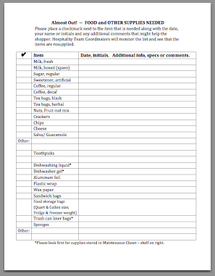

Trash/Garbage – Recycling – Composting

Our Fellowship makes every effort to recycle, reuse or compost at UUFC.

Trash/Garbage
- Please check the bottom of containers for a recycling symbol (♺). If present, rinse and place items in recycling.

- There should be a bag in the trash can. Extra bags are under the sink.

- If trash bag is full, please remove it and place it in the larger City of Clemson roll cart located out front behind the wooden enclosure. Place a new trash bag in the trashcan.

Recycling
- Curbside pickup of recyclables is limited to the following items from our kitchen:
  - Bottle glass (no broken glassware)
  - All plastic items, typically beverage bottles and jugs but also clear plastic food containers.
  - Metal food and beverage containers, including aluminum soda cans
  - Clean cardboard, both corrugated and pressboard packaging materials

- Remove caps and RINSE everything before placing in the large green recycling bin under the counter. (Peace Church places the recycling bin by the curb on Sunday evenings for City pickup on Monday mornings).

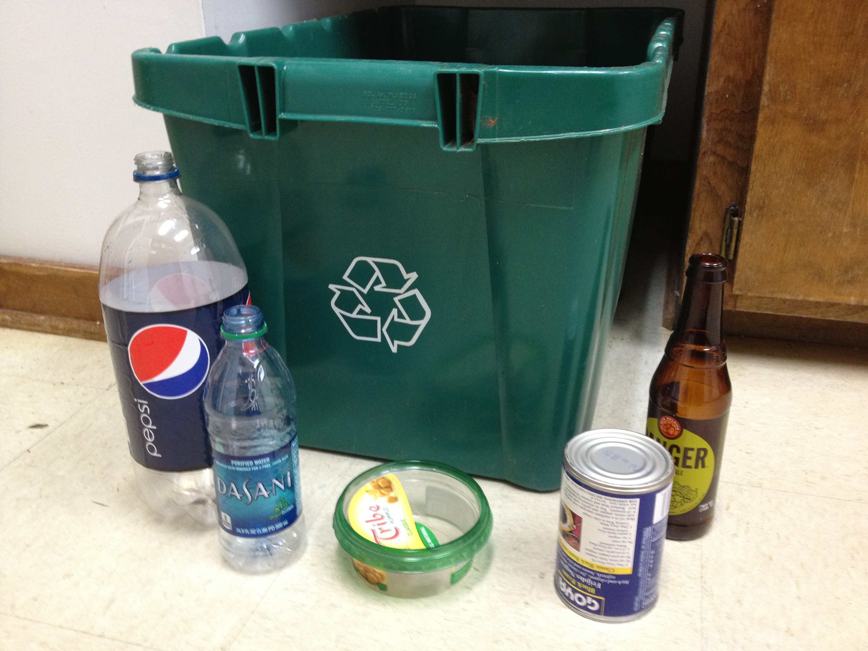

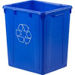
- Note: Paper (Bulletins, newspapers, magazines, office paper) should NOT be placed in green bin but rather in the blue paper recycling receptacles placed throughout the building

Not Recyclable: Soiled or wet paper towels, tissues and napkins are NOT recyclable – they are garbage!

- If you are willing and able to recycle other items at a convenient city/county recycling drop-off center, please take those items with you, especially corrugated cardboard such as pizza boxes.
  - Pizza boxes are problematic as they attract roaches and other vermin when left in the building. Please bag and place in trash receptacles outside.

Composting – Revised October 2014

A 3-bin composting station was built in 2011 to demonstrate the ease with which nutrient rich compost can be created from organic matter, typically kitchen waste and plant material from yard maintenance. We asked kitchen users to place coffee grounds, tea bags, dry leftover snacks, fruit/vegetable scraps in a stainless steel compost pail located near the kitchen sink. Kitchen cleanup included emptying the compost pail into/onto the 3-bin composting station at the front of the building.

Alas, after 3 years of trial (and error!) UUFC has decided to abandon onsite composting.

If you are inspired to remove compostable matter to your own home composting bin or garden --coffee grounds are great spread around plants! -- please do so. Please collect the coffee grounds, etc. in a plastic bag and remember to take the bag with you!

Closing Checklist

- Check to see if you are the last one in the building. Sometimes people are in the Sanctuary or a restroom.

- Check to see that all lights throughout the building are turned off and that water is shut off in all bathrooms. Please do not leave the building if water is running continuously in a bathroom toilet tank. Fix it yourself or find someone who can come over immediately to address the problem. Running water is wasteful, unfriendly to Mother Earth and expensive!

- Make certain oven and burners on stove are turned off.

- Make certain the Bunn coffee brewing unit is unplugged and water valve is turned to the off position.

- Make certain all doors are locked: two front doors, double exterior doors in Social Room, RE hall door to the outside deck, and library sliding glass doors.

- The front doors near the sanctuary and the patio need hex keys or Allen wrenches - to pop the bars on the doors. Hex keys/Allen wrenches are located on hooks beside those doors. 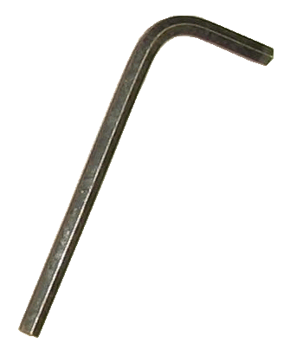

- If you see a repair or maintenance problem leave a message at the UUFC Office via voicemail (654-5959) or email at UUFC (uufcadm@gmail.com).

Please! Do not leave the building before locating a repairperson if water is running continuously!

APPENDICES

Instructions for BUNN Coffee Making System

- Plug the unit into the receptacle behind it.  Note: There is an electric toggle switch on the back of the unit. This switch should be left in the ON position at all times. Do not turn the electric toggle switch off. | 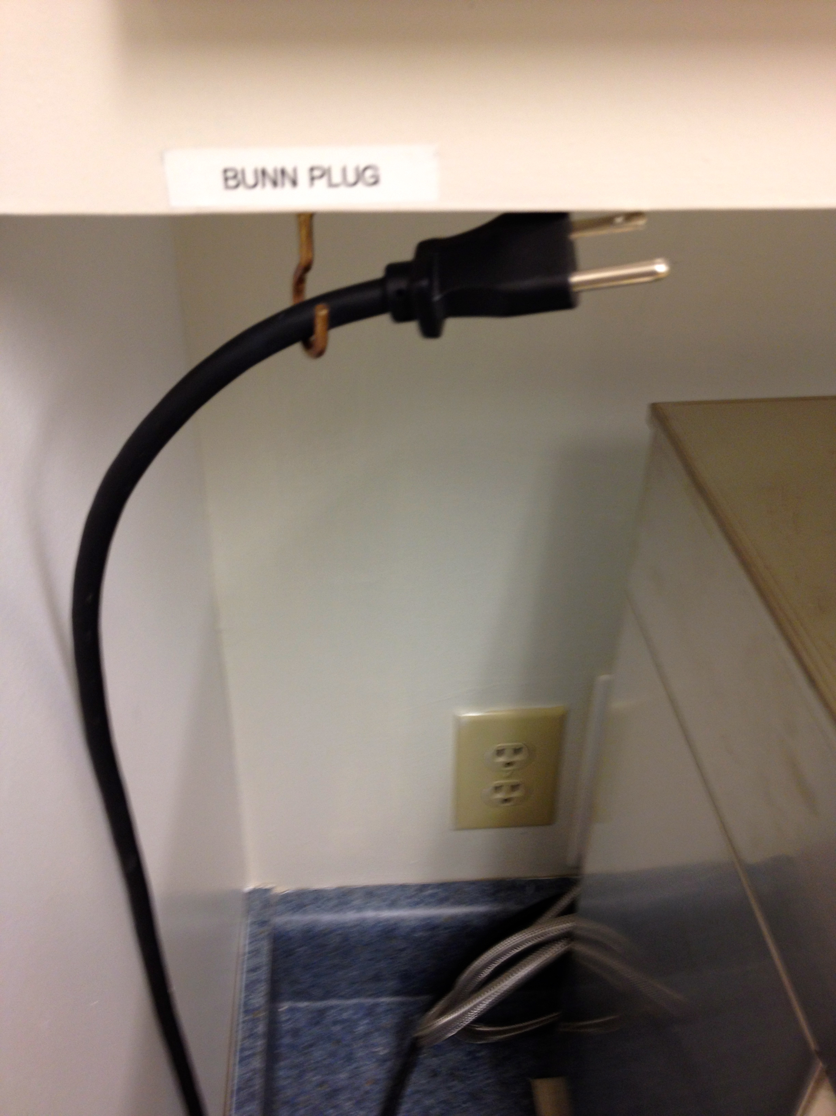
- Turn ON the white water switch, located on the wall behind the unit, to the ON position. ON is perpendicular to the wall. | 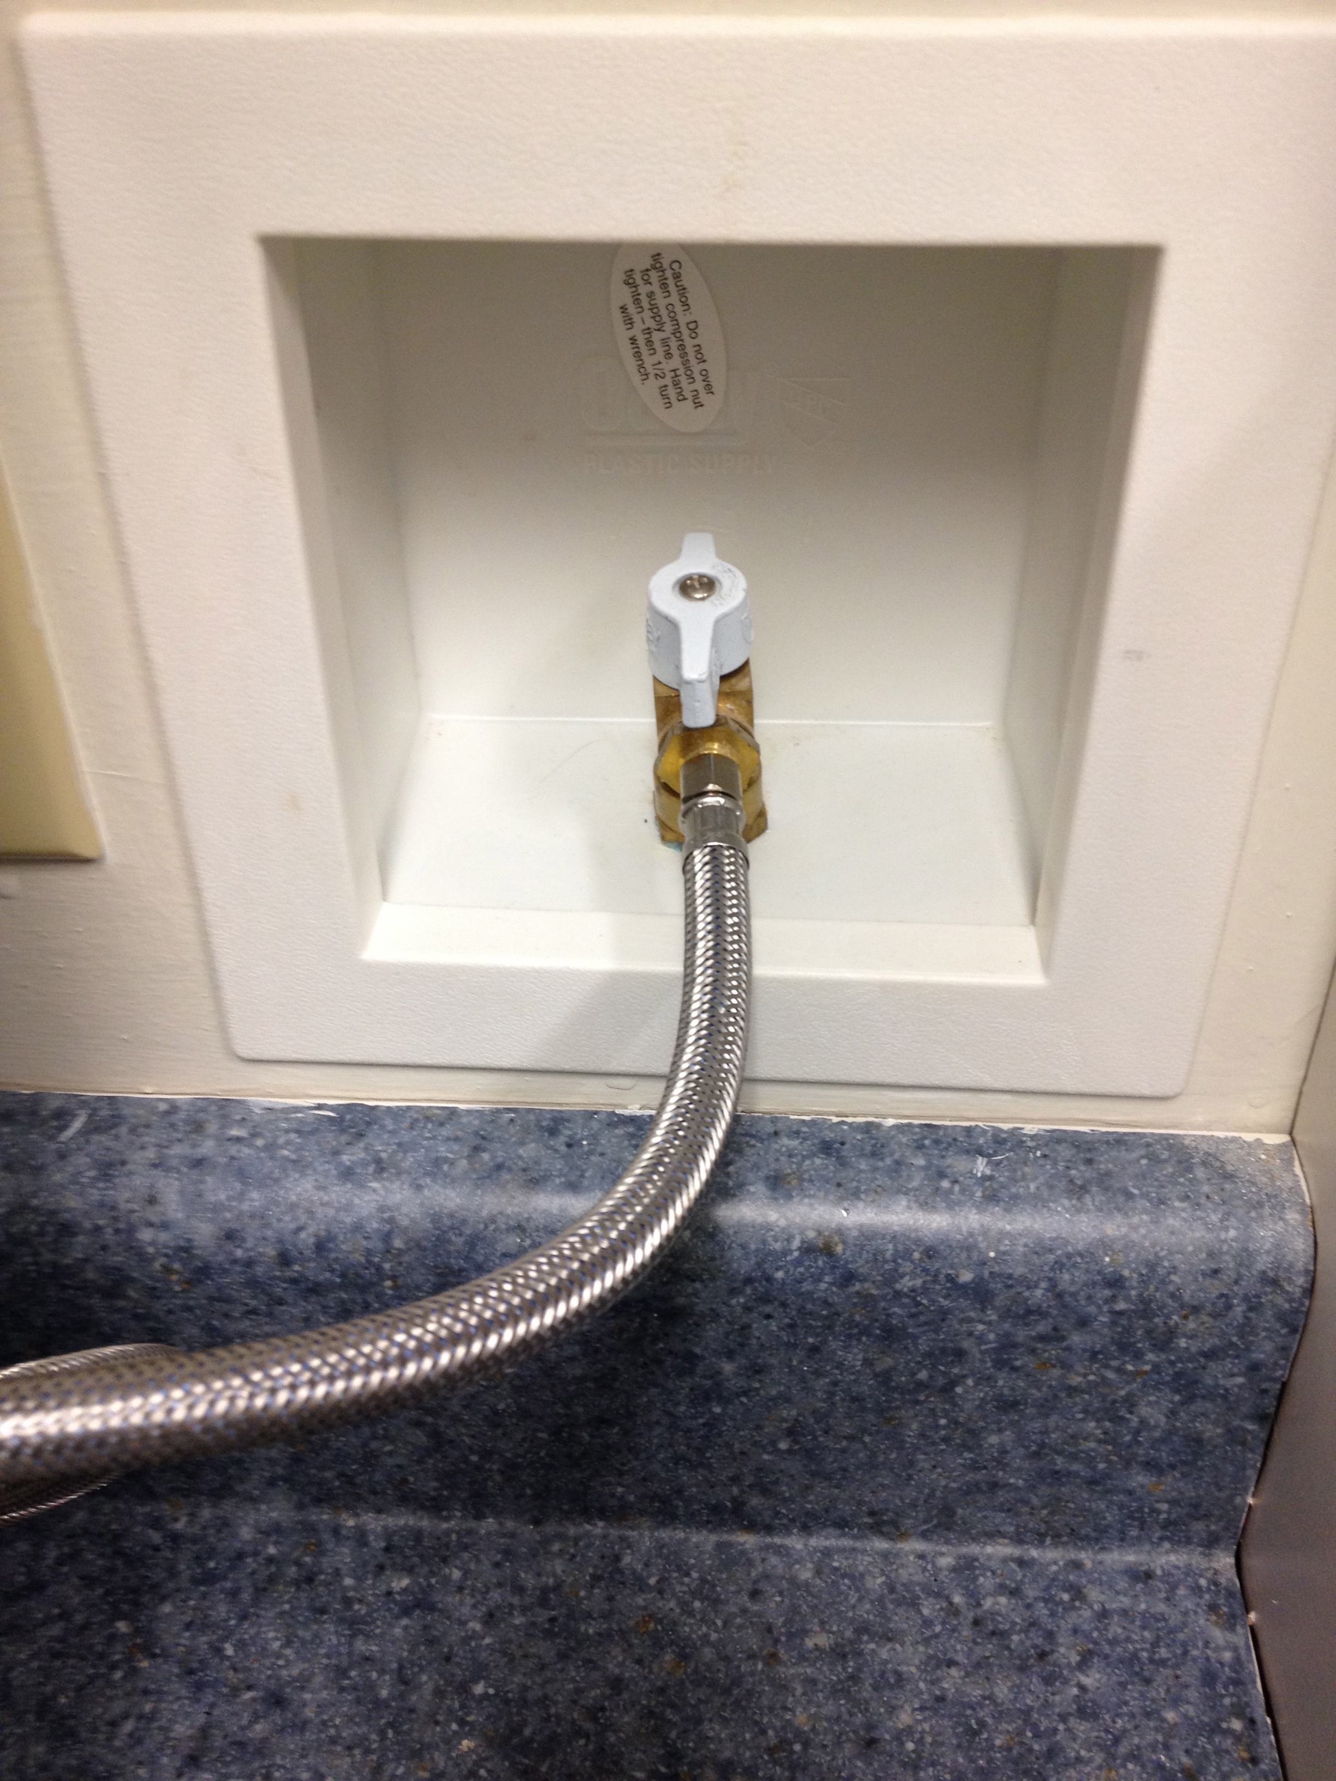
Press Enable Brew on the left of the display panel. Red light will come on indicating water is being heated in the reservoir. | 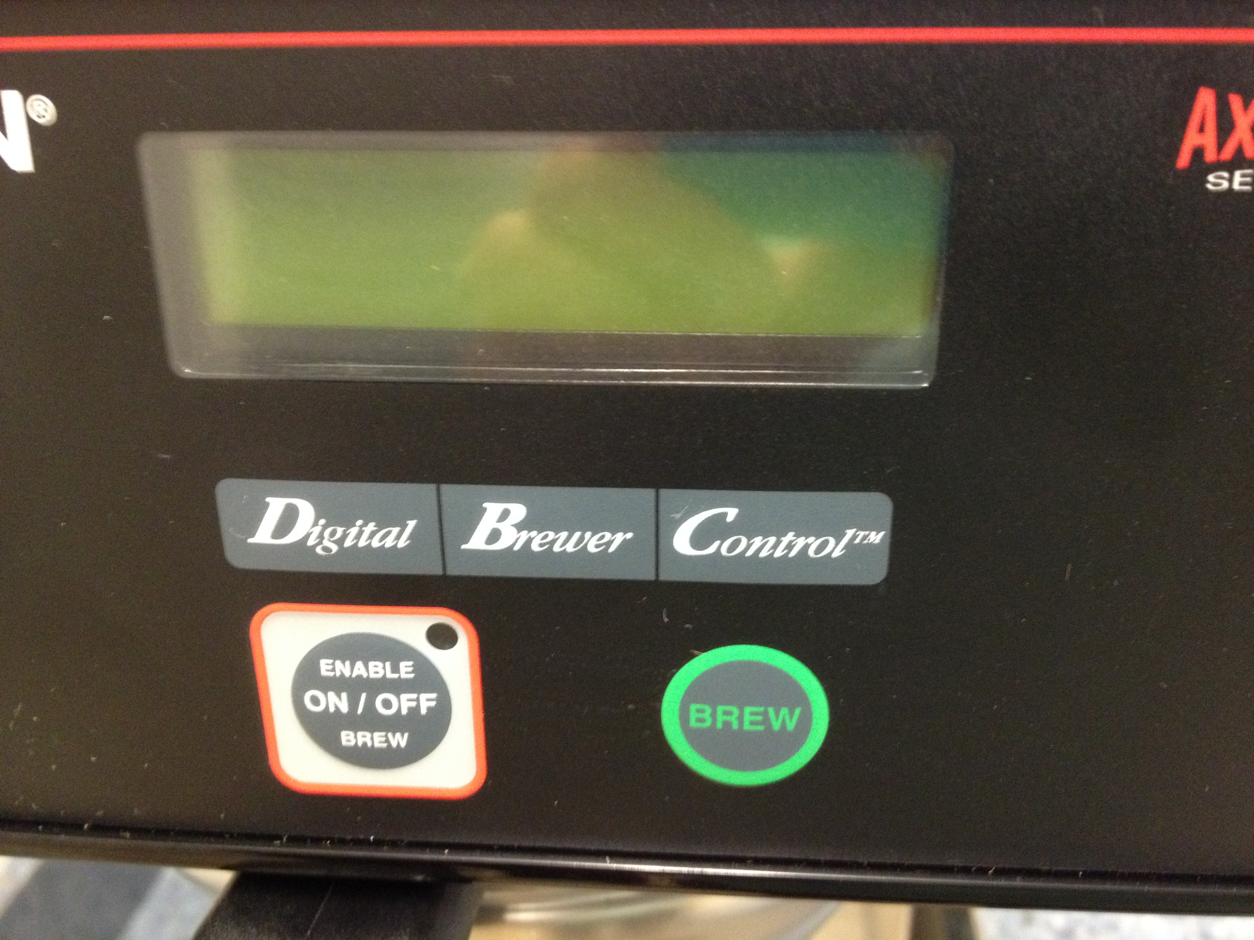
- Locate the metal funnel, either on top of the unit or in the dish drainer. Place a paper filter, found in the cabinet above the unit, into the funnel. Fill with a 1 cup of ground coffee, found in the left hand cabinet above the unit; shake or tap on the counter to level the coffee; slide the funnel into place. | 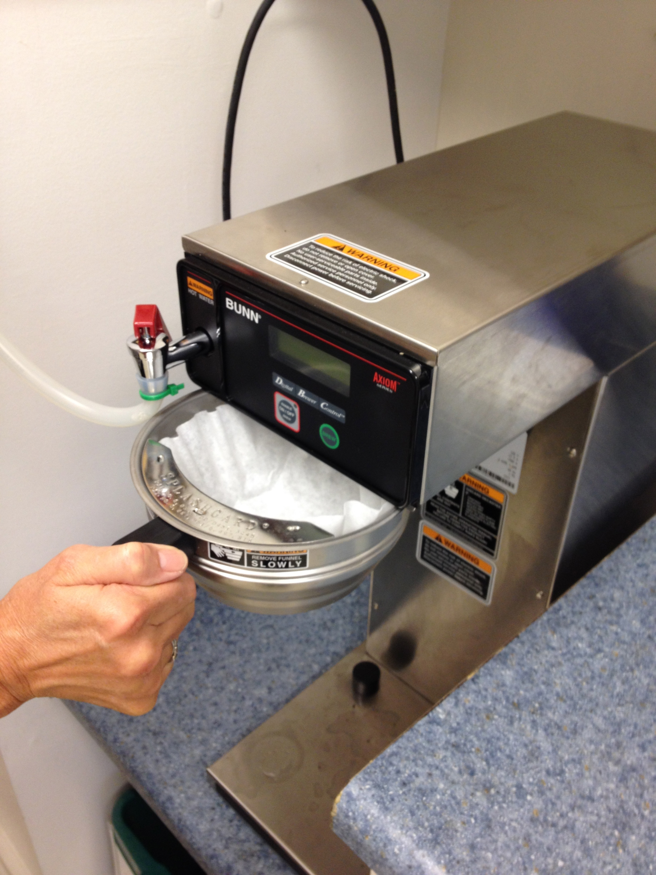
- Get an airpot out of the bottom cabinet just to the right of the unit. Note whether it is marked Regular or Decaf or Water (blue top). Open the top and flip it back; do not remove the top/lid. Remove the stem assembly and place the pot under the funnel so that it aligns with the bumpers behind it. | 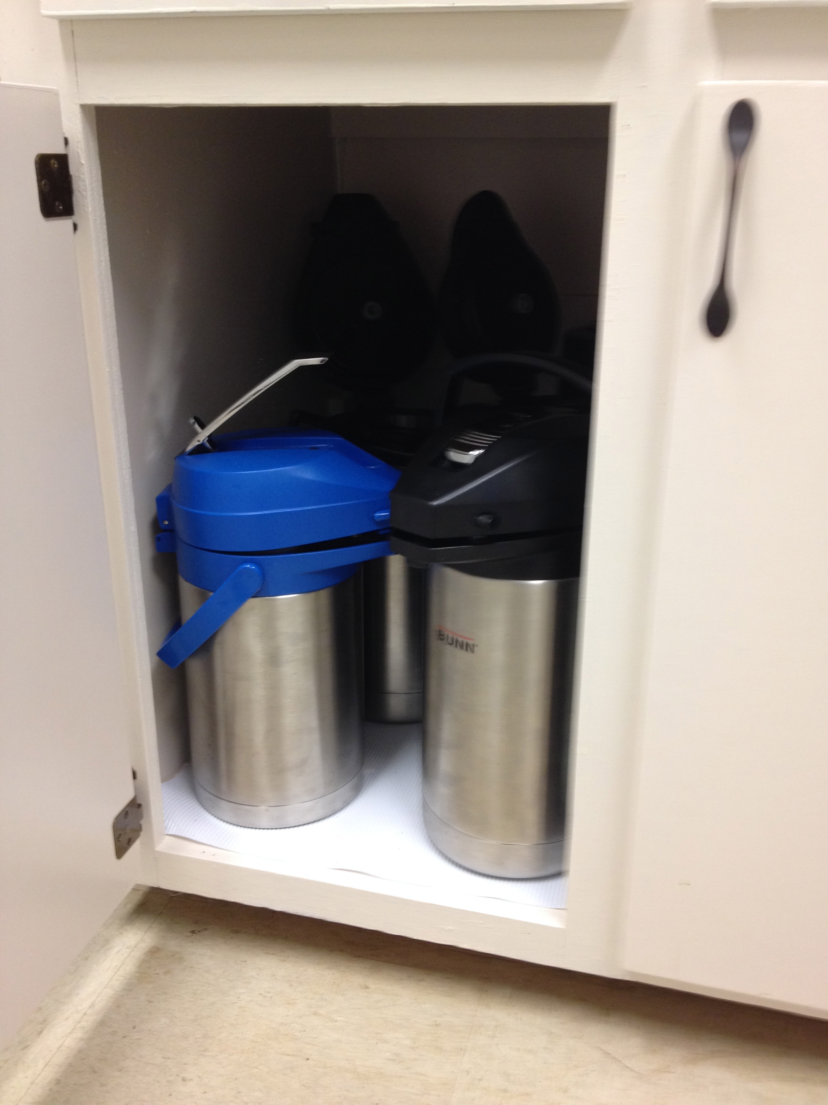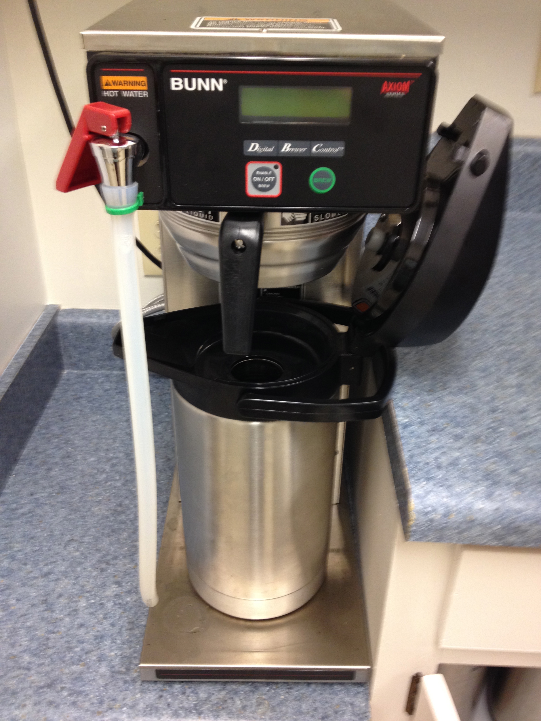

- Wait for the water temperature on the display panel to reach 197-200 degrees. It will take approximately 15 minutes for the water to reach brewing temperature for the first pot. After that, the temperature is maintained in the reservoir.

- When the display reads Ready to Brew, press Brew on the right of the display panel.

- Wait until brewing is complete and coffee has stopped dripping. The display will again read Ready to Brew. Remove the pot, replace the stem assembly, and close the lid. DONE!
- Dump the grounds and filter into the lined stainless steel compost pail.* Rinse out the funnel thoroughly, making sure that no coffee grounds are left under the rim. Place a new filter in the funnel, and add coffee, tap to settle grounds, slide funnel into brewer. Press Brew on the right of the display panel (no need to press Enable Brew again).
* You are welcome to take the coffee grounds home with you if you care to compost them yourself.

Make 2 airpots of regular coffee first, then 1 pot of decaf
COFFEE MAKING CLEAN-UP INSTRUCTIONS

- Rinse the funnel thoroughly with warm soapy water, making sure that no grounds are left under the rim. Place the funnel on top of the unit.

- Rinse the pots with warm soapy water and place them back in the bottom cabinet with the pumps loosely in place.

- Wipe off the undercarriage of the unit, removing any coffee stains and/or errant coffee grounds that may have splashed up on the undercarriage. | 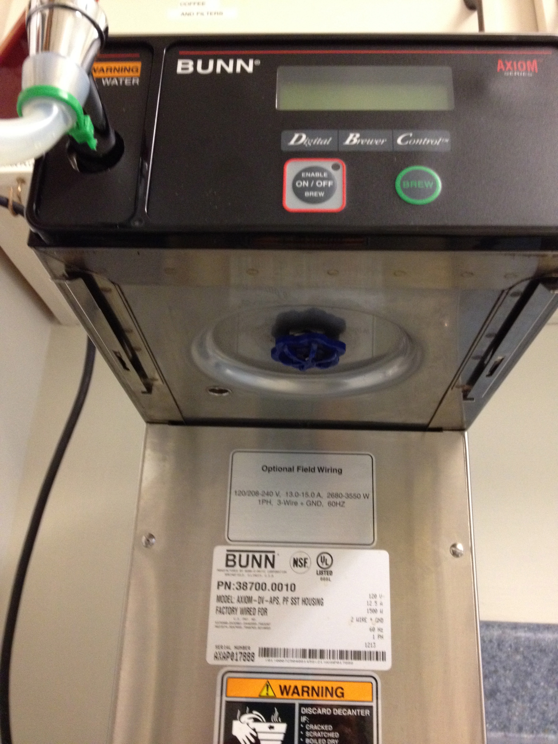
- TURN THE WATER SWITCH BEHIND THE UNIT TO THE OFF POSITION (parallel to the wall). | 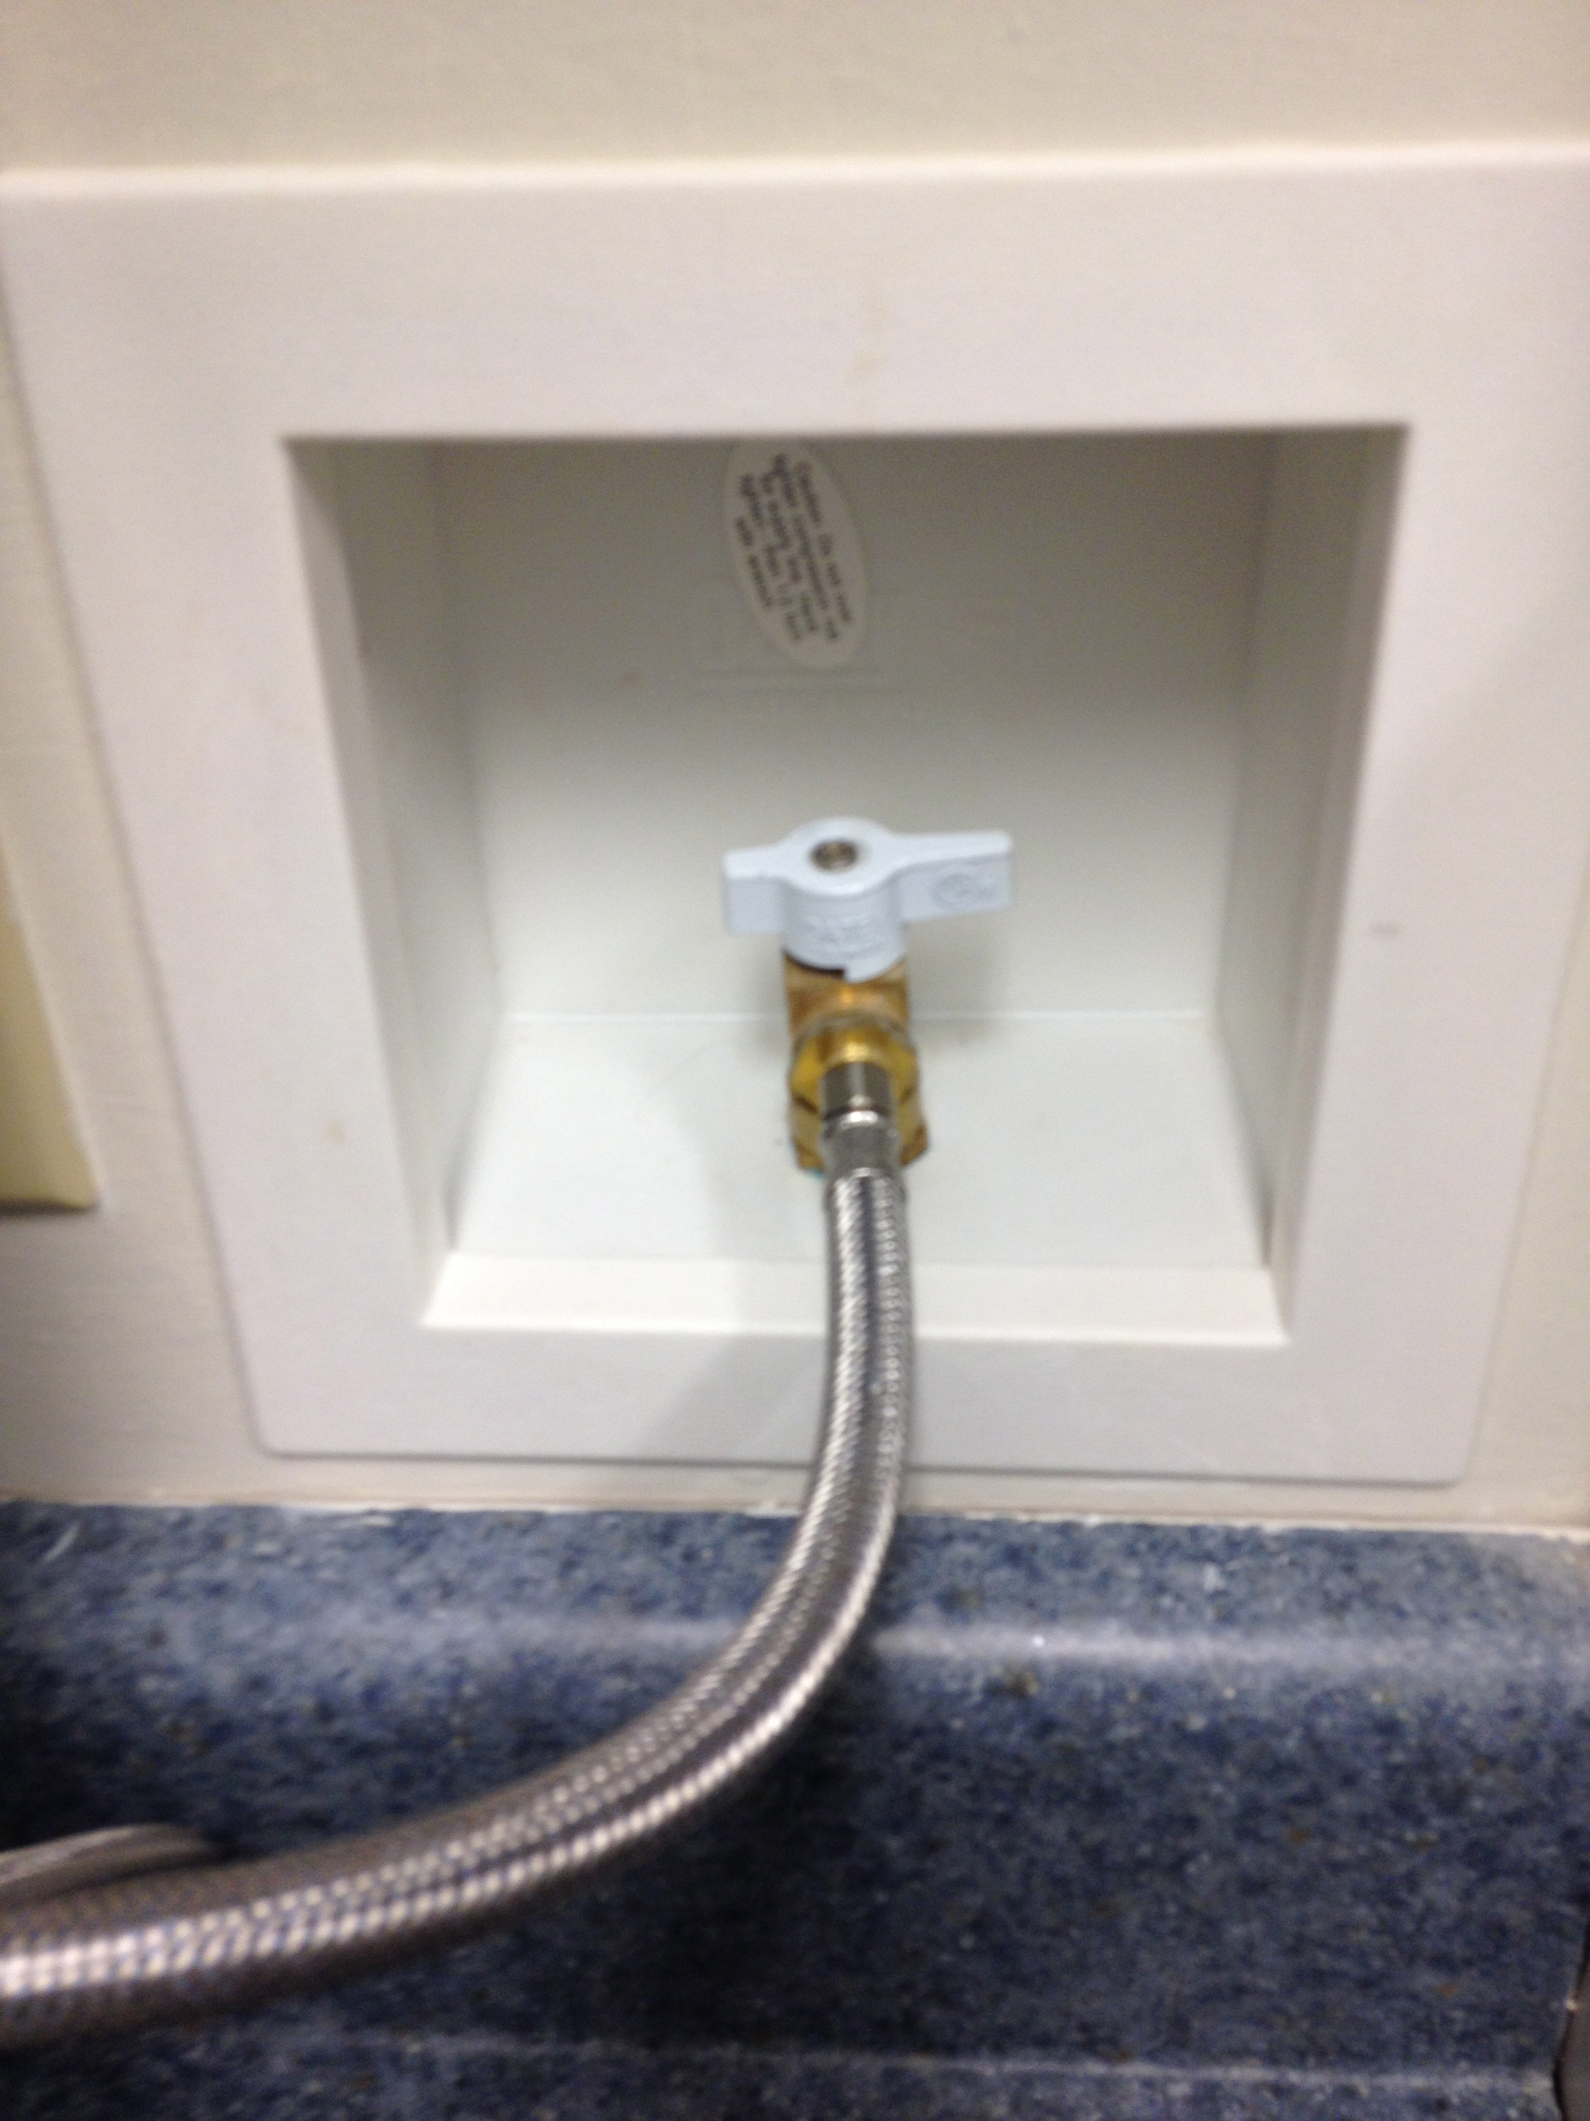
- UNPLUG THE UNIT. Hang the cord on the cup hook on the wall to the left of the unit along with the coffee-brewing instruction sheets. | 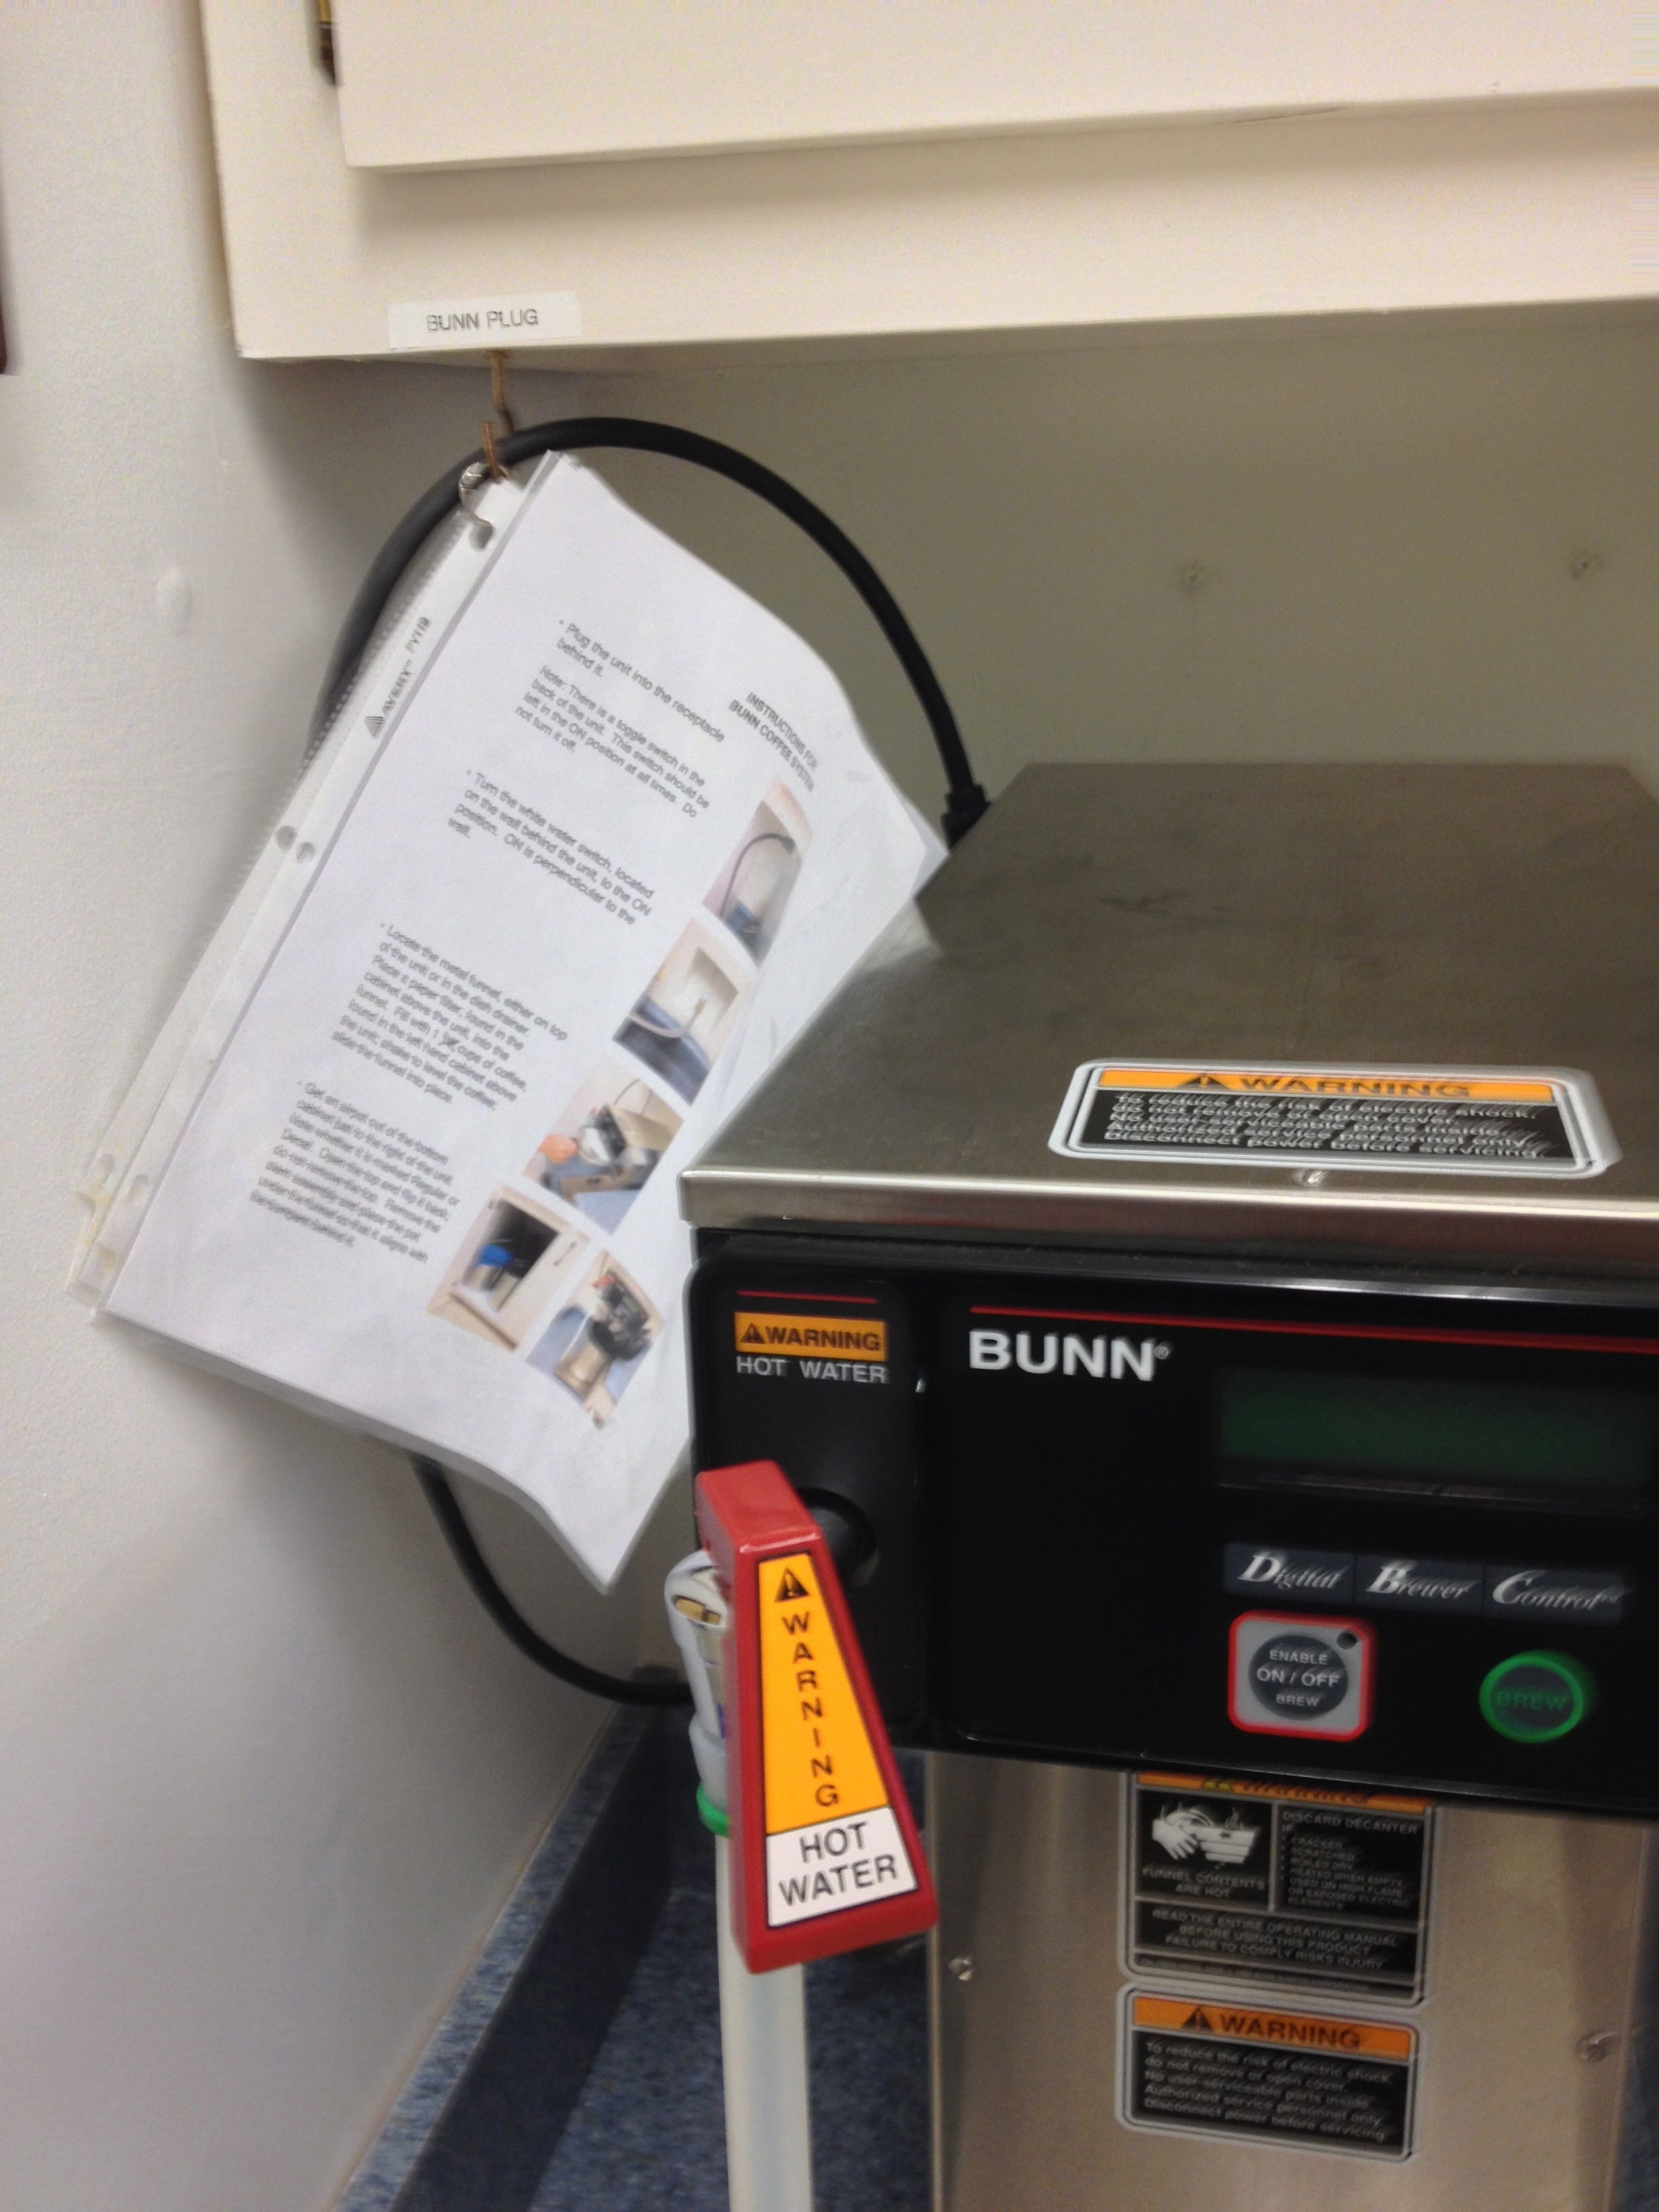

ADDITIONAL INFO AND INSTRUCTIONS

- Each full airpot makes 12-15 servings.

- Make a full pot every time. Please DO NOT attempt to make less.

- Please DO NOT attempt to change Brew Wizard settings.

